# ****Lab Steps****

## ****Task 1: Sign in to AWS Management Console****

1. On the AWS sign-in page,

**Enter IAM Username and Password** in AWS Console and click on the **Sign in** button.

1. Once Signed In to the AWS Management Console, Make the default AWS Region as **US East (N. Virginia) us-east-1.**

## ****Task 2: Exploring templates in an S3 Bucket****

1. Make sure you are in the **US East (N. Virginia) us-east-1** Region.
2. Navigate to the **services** menu in the top, click on **S3** in the **Storage** section.
3. Create a bucket **mycfbucket and upload file LAMP_template.json**
4. Open that bucket and you will see **LAMP_template.json** file.
5. Now copy the **Object URL** and save it in notepad.

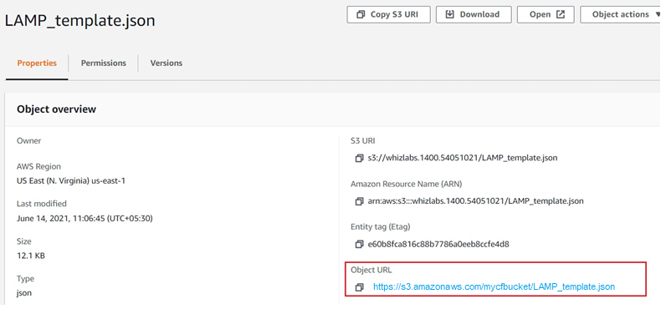

1. This given **LAMP_template.json** contains the JSON code for launching the LAMP Server using Cloudformation.

## 

## ****Task 3: Create Cloudformation Stack****

1. Navigate to CloudFormation. Click **services**, click on **CloudFormation** in the **Management and Governance** section.
2. On the CloudFormation dashboard, click on **create stack**.
   * Prerequisite - Prepare template : Select **Template is ready**
   * Specify Template :
     + Template source    **:** Select **Amazon S3 URL**
     + Amazon S3 URL    : Paste the URL copied from earlier.

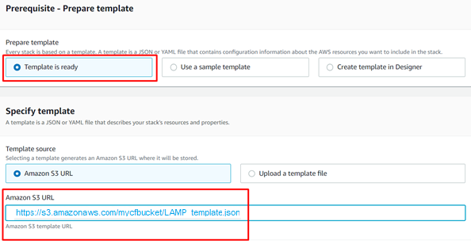

* Click on **Next.**

1. Specify stack Details
   * Stack name:Enter a unique stack name - **MyFirstCFStack**
   * Parameters
     + DB Name : Enter a database name - **MyDatabase**
     + DB Password : Enter a database password - **myCFdb123**
     + DB Root Password : Enter database root password - **myCFdbroot123**
     + DB User : Enter the database username - **myCFDBUser**
     + Instance Type : Select **t2.micro**
     + Key Name : Select the key from the list name **mytest-key**
     + SSH Location : Enter **0.0.0.0/0**
     + Click on **Next.**
2. Configure stack options :
   * Tags: Click on add new tag
     + Key : Enter **Name**
     + Value : Enter **MyCF**
   * Permissions: No need to select for this lab, leave it blank.
   * Leave all other configuration fields as **default**.
   * Click on Next.
3. **Review:** Review your stack details and click on **Submit.**
4. Once you have clicked the create button, you will be redirected to the CloudFormation stack list. A sample screenshot is provided below.

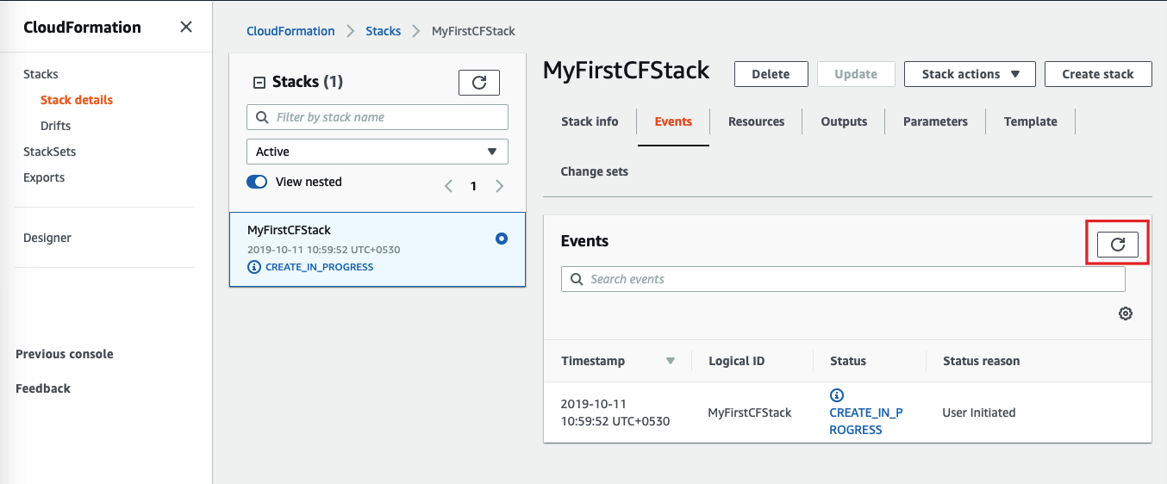

1. Status: You will see the status **CREATE_IN_PROGRESS.**
2. You need to wait around 1-5 minutes to complete the stack resource creation.
3. Click on the **refresh** button to see the updates.
4. Once your stack status changes to **Create Complete.**

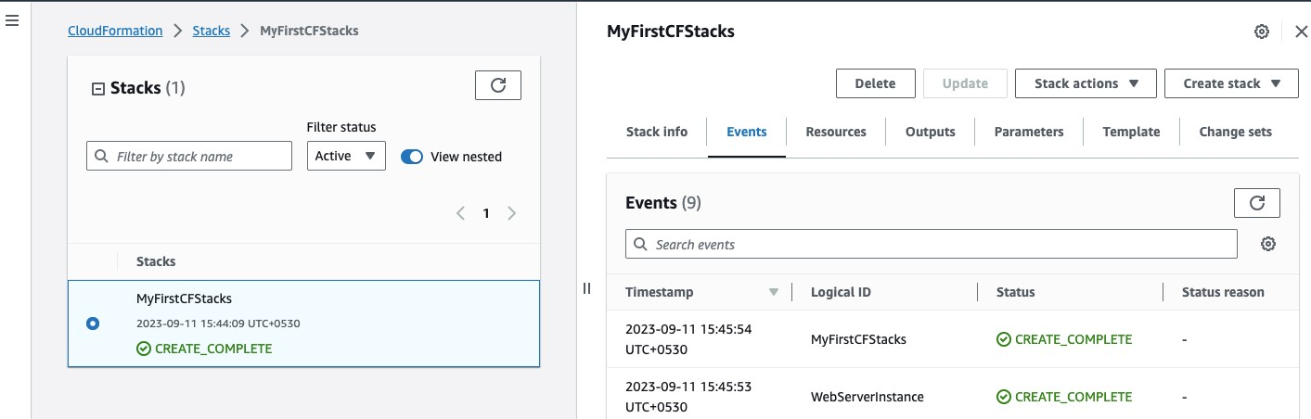

## ****Task 4: Testing****

1. Navigate to the **outputs** tab and you will be able to see an **URL** similar to below. Click on the URL. This will take you to your server's home page.
   * **http://ec2-18-212-56-170.compute-1.amazonaws.com/**
2. If you see the PHP info and your database connection, it means you have completed a LAMP server setup with AWS CloudFormation. Sample screenshot provided below:

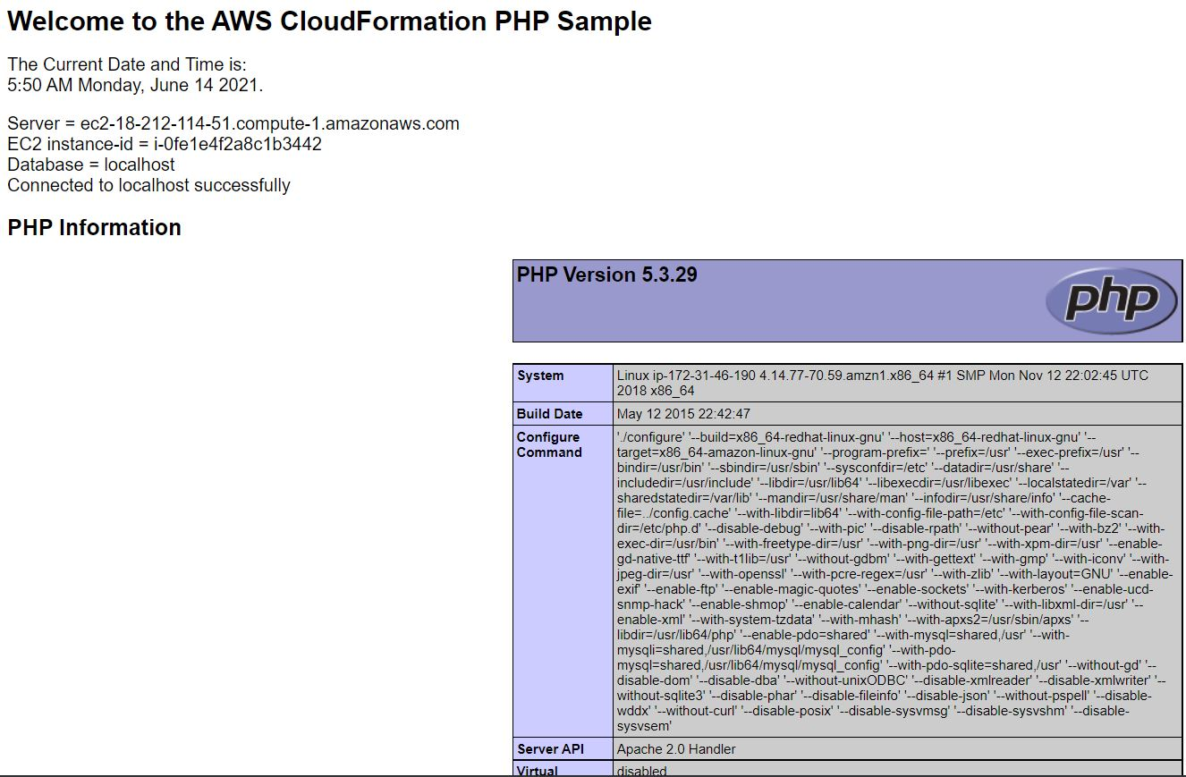

### ****Do you know?****

By using CloudFormation, you can manage your infrastructure more efficiently, reduce manual effort, ensure consistency, and achieve faster and more reliable deployments. It provides a scalable and flexible approach to infrastructure provisioning and management, making it a valuable tool for both small and large-scale AWS deployments.

# ****Completion and Conclusion****

* You have successfully created a Lamp server setup using a new Cloudformation Stack with the help of the JSON template provided in the S3 bucket.
* You have successfully tested the new lamp server created by CloudFormation.